CaptionCall 67TB
Office/Home Phone
Weight: 4.5 lbs
Package Measurements: 14x12x6
Spanish and English Captions
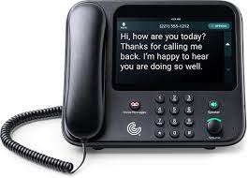
Interested? Contact the Assistive Technology/Durable Medical Equipment program at 419-885-5733.

