Local funding comparison to peer agencies in Ohio large urbans:
Cleveland, Columbus, Akron, Dayton, and Cincinnati. TARTA is also the only agency that receives its funding source from property taxes and not sales tax.

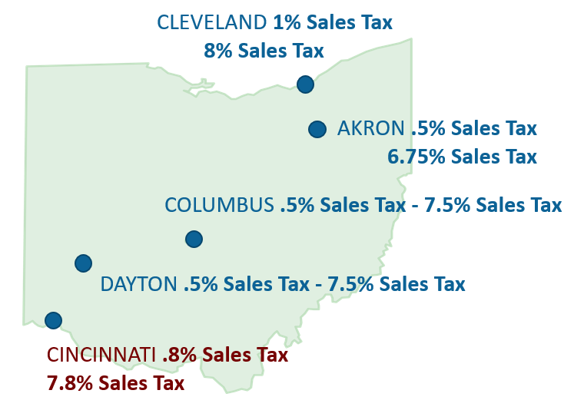

Current annual property tax revenue:
$13.5 million
Declined from $18 million in 2008

Total annual operating budget:
$29 million (pre-COVID 2016-2019)
*Funded with property tax revenue, federal capital funds $6.5+million, fare revenue, Toledo Public School and University of Toledo contracts.

Proposed sales tax rate for TARTA:
0.5 percent

Expected annual revenue for TARTA from a sales tax:
$32 million

Repeal existing property tax millages and replace with sales tax

Benefits of Public Transit:
Economic Development Workforce Development
Mobility Opportunities Improve Quality of Life
Access to Jobs, Education, Medical Services, Shopping

HB 74 (2-year Transportation Budget) becomes law on 6/30

Includes statutory language change for majority consent (from unanimous) to add Lucas County and place a .5% sales tax on the November ballot

HB 74 Supporters (Business and Community Leaders)

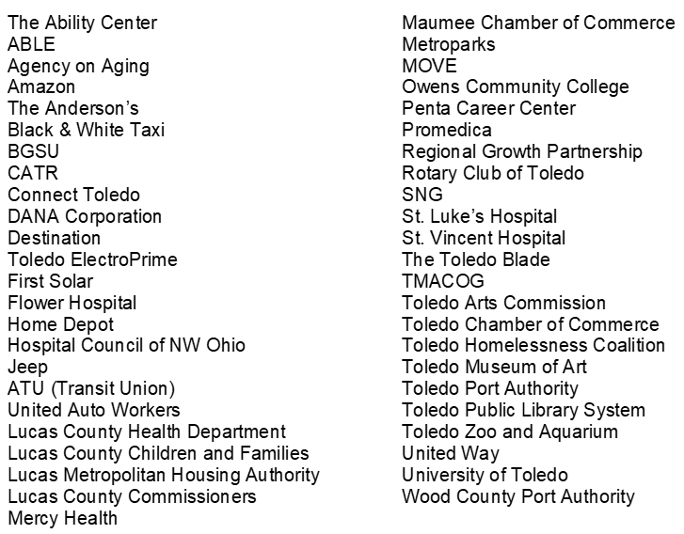

HB 74 Supporters (Elected Officials)

