Thank you for your interest in the Youth Leadership Forum (YLF). Information, instructions, and the YLF application are below. If you have any question or need assistance, please contact Lisa Broseke, YLF Site Coordinator at lbroseke@abilitycenter.org or (419) 885-5733 x145

1. To be eligible for the Youth Leadership Forum, students must:
(a) have a disability;
(b) be, at minimum, in the 11th or 12th grade as of December 2021;
(c) have demonstrated leadership potential in school and the community;
(d) eligible for services with Opportunities for Ohioans with Disabilities; and
(d) a resident of Ohio.
2. Student applicants must complete and submit the following application packet no later than APRIL 30th, 2022. Applicants will receive communication (e.g., an email, phone call, etc.) confirming their application materials were received.
3. Semi-finalists will be selected and contacted by telephone to arrange a personal interview. The interviews will be conducted by a selection committee. Interviews will take place prior to MAY 20th, 2022.
4. All applicants will be notified by email, mail, or phone call whether they have been selected to attend the forum.
5. This year’s YLF will be held at the Main Branch of the Toledo Lucas County Library (325 N Michigan St. Toledo, OH 43604)

Ohio Youth Leadership Forum (YLF)
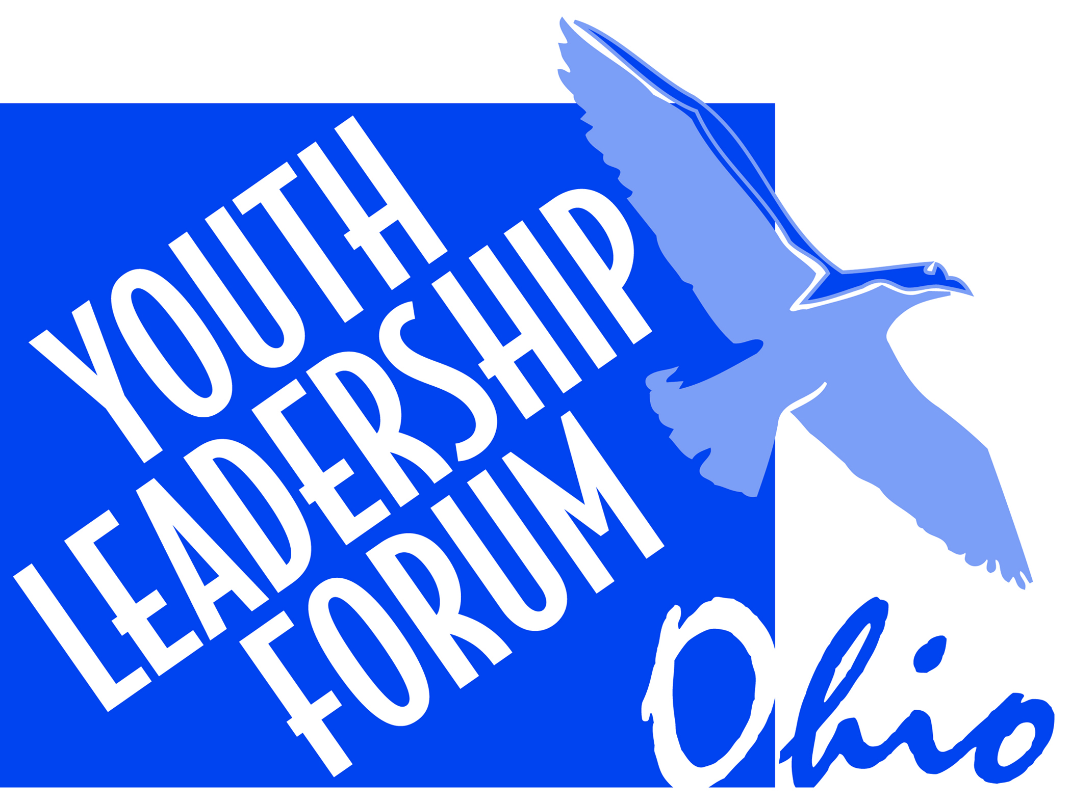
Toledo, OH
June 21st to 24th, 2022
Hosted by:
YLF Application for Students with Disabilities
Deadline for Application Submission: APRIL 30th, 2022
Personal Information
Student’s name (First, Middle, Last): |  |  |  | Suffix (e.g., Jr.) |  |  |  |  |  |  | *Preferred Name
Date of birth: |  |  |  | Age: |  |  |  |  | T-Shirt Size:
Student’s address: |  |  |  | City: |  |  |  |  |  |  | County:
State: |  |  |  | Zip Code:
Student’s mailing address, if different than above: |  |  |  | City: |  |  |  |  |  |  | County:
State: |  |  |  | Zip Code:
Student’s email address: |  |  |  | Parent/Guardian’s email address:
Student’s phone number: |  |  |  | Parent/Guardian’s phone number:
Preferred Method/Mode of Communication?  Braille  Email  In-Person |  |  |  | Phone  Text  Virtual  Not Listed, Please Specify:
Preferred Language?  American Sign Language  English  Somali  Spanish  Not Listed, Please Specify: |  |  |  | Are Interpreter Services Needed?  No  Yes, Indicate language:
School Information
Name of high school: |  |  |  |  |  | Grade level in December 2021
School address: |  |  |  |  | City:
County: |  | District: |  |  |  |  |  | Zip Code:
School telephone number (include area code): |  |  | High school Intervention Specialist/Counselor’s name:
Intervention Specialist/Counselor’s email address:
Cumulative grade point average as stated on your grade report:
Disability Information
Disability (medical diagnosis):

Age at or date of onset of your disability: |  |  |  |  |  | Are you a current OOD Participant?  Yes No
If yes, your OOD counselor/coordinator’s name:

If no, I understand that I must apply to Opportunities for Ohioans with Disabilities and be made eligible for services to attend the Ohio Youth Leadership Forum. Yes No

Gender, Race, Ethnicity

*Gender? Female Male Nonbinary Prefer not to specify Not Listed, Please Specify: |  |  |  | Pronoun Preference? He/him/his She/her/hers They/them/theirs No preference Prefer not to specify Not Listed, Please Specify:
Race (Select all that apply):  African American/Black  American Indian/Alaska Native  Asian  Native Hawaiian/Other Pacific Islander | White  Prefer not to specify  Not Listed, Please Specify: |  |  |  |  |  |  |  |  | Ethnicity (Select one):  Hispanic/Latinx  Not Hispanic/Latinx  Prefer not to specify  Not Listed, Please Specify:
Extra-Curricular and Community Activities Below, please list your extra-curricular and community activities. This may include any offices you held, club memberships, after-school activities. List the length of involvement, grade level you were in at the time of participation. (Use extra sheets if necessary.)
Name of Activity |  | Adult Contact |  |  |  |  | Date From |  |  |  |  | Date  To | Grade Level
Employment Experiences Below, please list your work experience, if any. List the length of employment and grade level you were in at the time of participation. (Use extra sheets if necessary.)
Letters of Recommendation
Please attach two letters of recommendation which describe your leadership skills and potential. One letter must be from a high school representative. The other letter must be from a community representative (e.g., OOD Counselor) outside your school. Below, list the name, position/title, organization, and telephone number of the two people who are writing the letters.
Name |  |  |  | Title
Organization or business |  |  |  | Telephone #  (include area code)
Name |  |  |  | Title
Organization or business |  |  |  | Telephone #  (include area code)
Required Responses
Your answers to the following questions will be used to assess your readiness to participate in the youth leadership forum.
Note: If filling out by hand, write your responses on separate pieces of paper and attach to your completed application. Feel free to submit responses in written, video, audio form or other creative formatting (i.e., poster board).
- Qualifications: Explain why you are qualified to be a forum delegate and why you want to attend.

- Positive Influences: Describe two people who have positively influenced your life. How have they done so? (Family members, teachers, counselors, friends, public officials, or celebrities are appropriate examples.)
- Experiences as a person with a disability: Describe two important experiences you have had as a person with a disability. These can be positive or negative experiences. (Please be specific about how your examples relate to your disability.)

- Future Plans: Describe your plans for after high school graduation.

Checklist
Please use the checklist below to make certain your application packet is complete. All questions must be answered and requested letters and information provided.
Application (all questions answered)
Two letters of recommendation
Required responses to the four questions
By signing this application, I acknowledge that confidential personal information may be obtained or released by OOD and/or OOD VR Contractors to Partners and Employers on my behalf.
Date:
Student’s Signature:
Parent or Legal Guardian Signature:
Thank you for completing this application. Please mail or email the completed application packet to the address below. If you have any questions, please contact Lisa Broseke, YLF Site Coordinator at lbroseke@abilitycenter.org or (419) 885-5733

