InfraPort Sennheiser Cordless TV Headphones
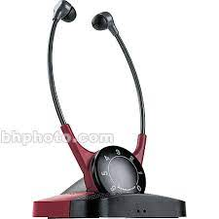
Interested? Contact the Assistive Technology/Durable Medical Equipment program at 419-885-5733.

