How to Make a Fleece Tie Blanket

Materials needed for fleece tie blanket:
- 2 pieces of coordinating fleece fabric
- Scissors
- Ruler or Tape Measure
Instructions:
- First, lay both of your fleece pieces (2 different patterns/colors) on top of each other, bright color side out. Cut off the selvage edge, That’s the edge that isn’t cut. Even out each piece of fabric, cutting together so they are the same size. Cut the pieces to 30” x 24”
- Keeping both pieces of fabric together, measure a 6″ square in each corner and cut out. Using a tape measure, lay it across the edge of the fabric.

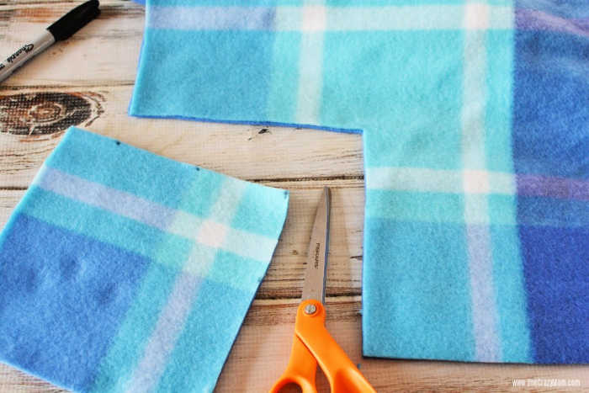
- Cut the strips, 1″ wide and 6″ long, making sure to cut both pieces of fabric at the same time.
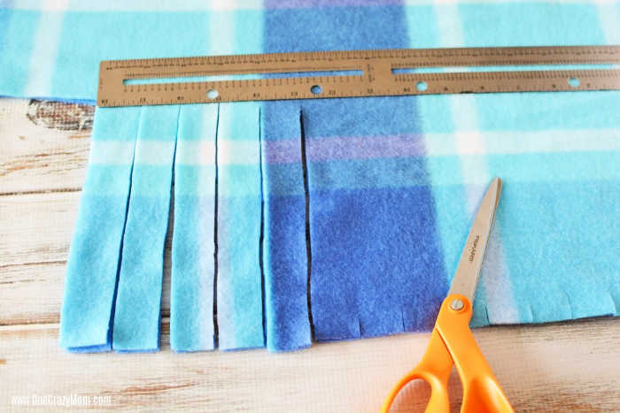

- Begin to knot the pieces of fabric. Any method of knotting is fine to fleece tie.
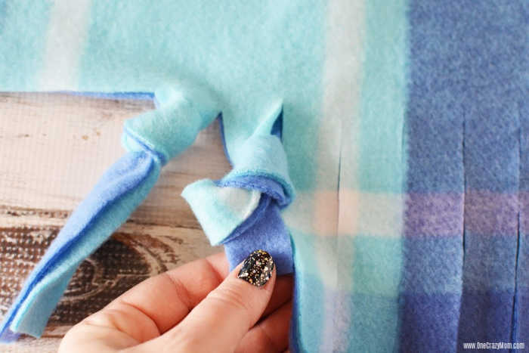

- Just make sure you do the exact same knot so they are uniform. I like to fold the tassels up and around to form a knot.
- If necessary, trim the ends of the tassels to even them up.

