How to Make a Handle Tug Toy

You will need:
A rotary cutter and cutting surface or scissors
A ruler
A sharpie
A rubber band
A weight
Cut 3- 3" strips of polar fleece cut from selvedge to selvedge
Fold your fleece in half matching selvedges. Measure a 3" wide strip and cut so that the folded edge is facing you and the selvedge is away from you. You should end up with one strip of fabric. Do this 3 times so that you have enough strips to braid. Keep them folded in half.
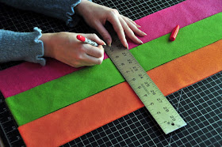
Line up your three folded strips with the fold end towards you. Measure 10" up from the fold and mark with the sharpie. Push aside the top layer of fabric and mark the lower layer as well. When you unfold the strips, there should be 2 marks on each (approximately) 20" from each selvedge and each other.
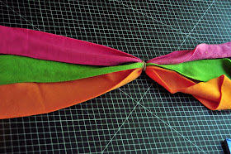
Line up ends and find your sharpie mark. Pinch at the mark and rubber band here. The rubber band will not be centered, put the shorter tails away from you.
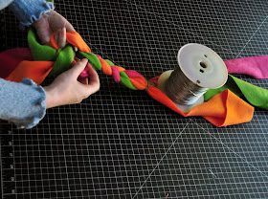
Place a weight above the rubber band to hold everything in place while you braid. Braid *tightly*until you reach the next mark. If you are using different colors, make sure your strips are in the same order that they started in. **A loose braid will allow too much stretch in the tug**
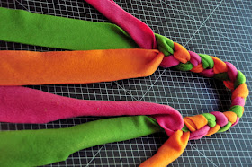
Remove the rubber band. You should now have something like this - a centered braid with two loose ends. Look at the braid, it has a direction where the fleece makes up pointing or down pointing Vs. These Vs need to be pointing in the same direction, if they are not, flip one end of the braid horizontally.
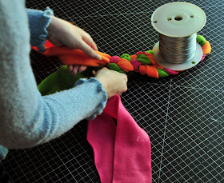
Match the colors and begin to braid them tightly as if each pair of strands were one.
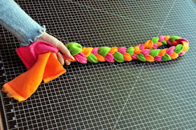
Grab the ends of your braid and tie an overhand knot near the ends. It might seem like a bulky knot, but it will work. You will see that a loop has formed on one end to serve as a handle for either you or your dog (or cat?).
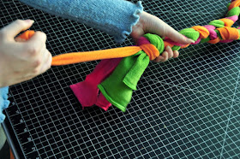
Take each piece of fleece individually and pull to tighten up the knot. It is now unlikely that a dog will untie it right away.
Trim the ends to a uniform length, and it's ready!

