Honeywell Home Smart Thermostat
Control thermostat usung smartphone and wifi
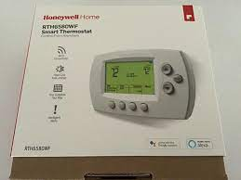
Interested? Contact the Assistive Technology/Durable Medical Equipment program at 419-885-5733.

