SonicAlert SonicLink Deluxe Remote Receiver
Makes it easier for people to turn on/off lamps
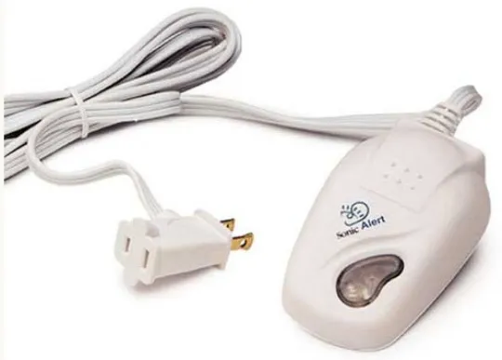
Interested? Contact the Assistive Technology/Durable Medical Equipment program at 419-885-5733.

