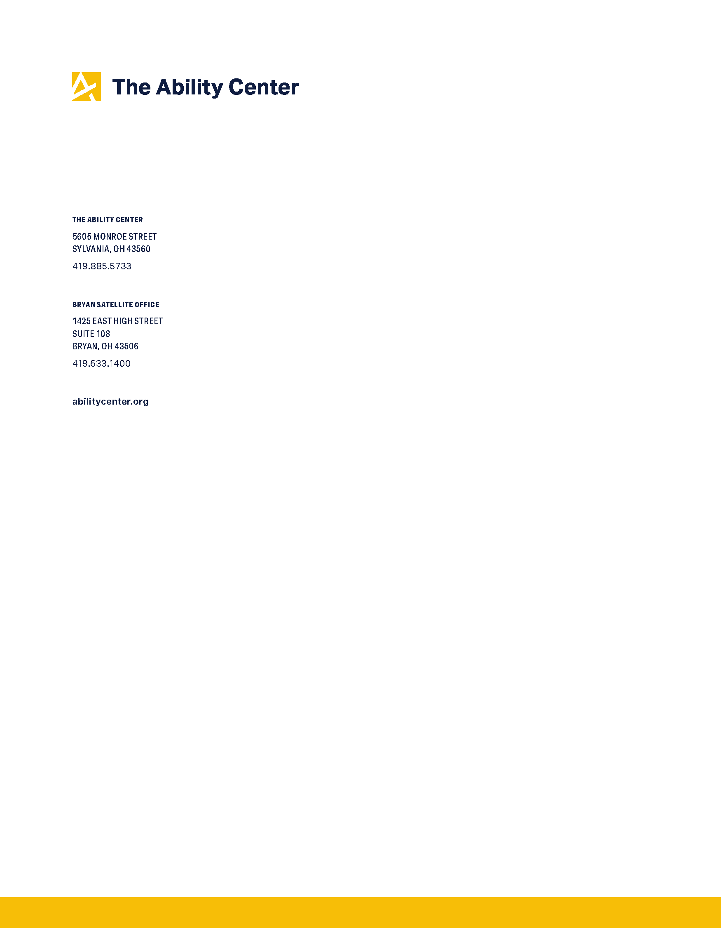
April 26, 2021

ATTN: Senator Hassan, Senator Brown, Senator Casey, and Representative Dingell

SENT VIA E-MAIL TO: HCBSComments@aging.senate.gov

RE: The Ability Center HCBS Access Act Discussion Draft Public Comment

Senator Hassan, Senator Brown, Senator Casey, and Representative Dingell,

On behalf of The Ability Center of Greater Toledo, thank you for allowing for public comment on the discussion draft of the Home and Community-Based Services Access Act (HAA). The Ability Center is a Center for Independent Living that serves seven counties in Northwest Ohio. Our mission is to advocate, educate, partner and provide services that support people with disabilities and help them thrive in the community. True to our mission, we are committed to ensuring people with disabilities are able live in equitable, inclusive communities. Therefore, we take great interest in assuring that people with disabilities are provided care in community-based settings whenever possible, and we are encouraged by your commitment to creating a robust Home and Community-Based Services (HCBS) system nationwide.

Introduction

In 2020, the Centers for Medicare and Medicaid Services (CMS) issued guidance reiterating the obligation of states to ascertain that people have access to Home and Community-Based Services as alternative to institutional care and congregate care settings. The COVID-19 pandemic has made the fulfillment of this obligation all the more crucial. In Ohio, 38% of all deaths due to COVID-19 have occurred in long-term care facilities. During the COVID-19 Pandemic, it has been safer for Ohioans to receive community supports in their own homes rather than in an institutional setting. We want
to ensure that no Ohioan is forced to stay in an institutional setting due to the lack of adequate community supports. It is important to the health and safety of all Ohioans that these individuals have safe and feasible alternatives to institutional and congregate care settings, and as a result, are able to safely transition out of these settings.

This draft of the Home and Community-Based Services Access Act (HAA) has been introduced at a critical moment in our country and has the ability to make these safe and feasible alternatives a reality to people with disabilities and the aging population nationwide. The following are The Ability Center’s recommendations and thoughts regarding specific elements and topics of the HAA discussion draft.

Advisory Panel

- We are pleased to see that the HAA discussion draft proposes forming a panel to advise states on HCBS that is made up of individuals with lived experience of using HCBS as well as providers.
  - We ask that the final draft of the legislation ensure that the composition of this panel is a majority +1 of members that are people with disabilities receiving home care services and home care workers.
  - We also encourage emphasis on diverse representation in terms of age, race, disability type, gender, geographic location, etc. when selecting members of the panel.
  - We ask that family members, as well as people with disabilities, are considered when thinking of individuals with lived experience of using HCBS.

The minimum services and standards to be provided by state HCBS

- We would like to see expanded eligibility for HCBS based on on 1 ADL or IADL. The current draft of the bill recommends eligibility criteria of 2 ADL or IADL in order to receive services. However, it has been our experience that there are currently many people in Ohio who are eligible to receive Medicaid but who are ineligible to receive HCBS due to the eligibility criteria of 2 ADL/IADL. Furthermore, if language regarding activities of daily living is included in this federal bill, due to the current differences in eligibility across states, eligibility criteria should be less restrictive to ensure that people receiving services in the states who currently recognize eligibility at 1 ADL/IADL do not lose those services.

- We would like to see availability of direct care providers for IADLs like medication management and bathing, cleaning the home, etc., if these IADL’s are unable to be met due to a disability, including, but not limited to, a mental health disorder or a sensory processing disorder.
- We are happy to see that housing support, as well as non-emergency, non-medical transportation are included under “specified services” in this draft of the bill. We encourage the inclusion of these services in the final draft the bill, and also recommend that service animals be specified as a service covered under waiver, as they are a substitute for human assistance. Transportation, Housing, and Service Animals have not been emphasized in HCBS in the past, and it is important that these continue to be emphasized in the future to allow for full community integration.

- It is important that the finalized legislation (or the advisory panel) ensure that all states have an assessment system is person-centered and that takes each individual and their diverse needs into consideration when identifying the level of support or care individuals require. Standardized level of care assessments in many states, including Ohio, often exclude people from needed benefits because they do not meet one area or requirement, but do meet others. Computer algorithms used in multiple of states to assess level of need have cut crucial benefits to people who need them. People do not fit into algorithms.
Methods to ensure state Medicaid rates are sufficient to support required services and supports and to provide adequate pay for direct care workers, including personal care attendants and other in-home care providers

- Section 5, letter C, number 2 requires that states come up with a plan for a stable and high-quality work force, including a living wage.
  - We recommend a $15/hour minimum wage for in-home providers. However, it is important to ensure that if a wage increase makes an individual ineligible for benefits such as Medicaid and/or SNAP, that all workers are able opt into, and receive, healthcare and other benefits.
  - This plan must include more than just increasing wages. The plan should also be required to include recruitment, benefits, methods for advancement, etc.
  - Money needs to be put into recruitment of the health care workforce. Many people who receive in-home care report that the current workforce competes with jobs in waitressing and customer service due to higher pay in those fields. Furthermore, Direct Care Support workers need to be comfortable with people with disabilities and have the desire to help others. Several people with disabilities have reported that they have experienced Direct Care Support workers who left after one day on the job due to the job requiring more physical work than they were expecting and more dedication than they were willing to provide. State programs need to recruit students and professionals from health care and other disability fields in order to attract workers to the profession who are not only comfortable with people with disabilities, but who also have the desire to help, and who have the skills needed to provide quality care.
  - One recommended method of recruitment is recruitment from Universities – specifically recruiting students in the disability and healthcare fields. Allowing these students to receive college credit for providing care can be an effective recruitment strategy and allows for these students to gain direct experience related to their fields of study. Also consider students and new professionals to achieve credit toward licensure and/or degree by providing a certain amount of hours of in-home direct care.
  - There needs to be avenues for advancement within the direct care work force. While a worker can be promoted in waitressing and customer service jobs, there is currently no way for a Direct Care Support Professional to move up in their field or earn more money. Often, they are supervised by Registered Nurses, so they must go back to school in order to be hired into a supervisory role. Allowing supervisory roles without a nursing degree or giving college credit or money for additional education would assist in fixing this issue.
  - Direct Care workers need to not only be trained on technical aspects and basics of care, but also receive person-centered training specific to the needs of the individuals they serve, as well as education on how to interact with the disability and aging populations.
- Section 5, letter C, number 6 requires that states come up with a plan for carrying out education and activities on the availability of services through Aging and Disability Resource Centers and other similar entities. As a Center for Independent Living, The Ability Center would like to see Centers for Independent Living be included as one of those entities that carry out education and activities on the availability of services. Centers for Independent Living are required by federal law to be cross-disability, consumer-controlled entities and are in a good position to know what is needed in our Direct Care system.

HCBS infrastructure in states that support family caregivers, provider agencies and independent providers

- Instead of ensuring family and caregiver supports are reimbursed under HCBS, we recommend that family members are recognized as providers and are paid equally to other non-family providers and receive benefits. Often, family members provide the best care for people with disabilities or are in a position where they must provide care that can interfere with their own ability to work.

- We recommend safeguards so that individuals with family providers aren't trapped and families aren't using them for money/not letting them leave if they so choose.

- We would like to see incentives for agencies to prioritize providing quality care rather than prioritizing cost savings, keeping in mind that if rules and regulations are utilized as tools to ensure quality of care, not creating so many rules and regulations that it becomes difficult for agencies to hire and maintain good providers/workers.

The role of managed care in providing HCBS, in particular, issues such as network adequacy standards and ensuring that consumers can retain maximum autonomy to direct their care
- Managed care companies are often so incentivized to prioritize saving money and cutting costs that they don't provide individuals with services needed in order to live in their home. In Ohio, managed care companies are currently provided with an annual lump sum and are allowed to keep whatever money is left over at the end of the year. Because of this, we see managed care companies who are incentivized to deny expensive care, such as costly durable medical equipment and home modifications.
- We would like to see managed care companies that are non-profit and mission driven.
- We would like to see incentives for managed care companies to prioritize providing quality care instead of prioritizing saving money and reducing costs.
Other related policies and programs, such as Money Follows the Person, the Program of All-Inclusive Care for the Elderly (PACE), and spousal impoverishment protections.
- We would like to see the Money Follows the Person program (HOME Choice in Ohio) continue to be funded by the federal government in order to transition more individuals who want to live in in their community out of institutions and into their own residences.
Thank you again for allowing us to provide comment on the proposed bill. We believe that this bill will have a positive impact on those who rely on home and community-based services and supports. If you have any questions, please don’t hesitate to reach out to Katie Shelley at kshelley@abilitycenter.org, (419) 885-5733 x 120, or Katherine Hunt Thomas at kthomas@abilitycenter.org, (419) 885-5733 x 254.

Sincerely,

/s/ Katherine Hunt Thomas, Director of Advocacy and Disability Rights Attorney, The Ability Center of Greater Toledo

/s/ Katie Shelley, Disability Rights Advocate, The Ability Center of Greater Toledo

Since April 2020 there have been 6,602 deaths in long-term care facilities of the 17,502 total deaths in Ohio. These numbers continue to change and are based on the data reported by the Ohio Department of Health on March 3, 2021. https://coronavirus.ohio.gov/wps/portal/gov/covid-19/dashboards/long-term-care-facilities/mortality
https://cdt.org/insights/report-challenging-the-use-of-algorithm-driven-decision-making-in-benefits-determinations-affecting-people-with-disabilities/

